**The Societal Conflicts in American Advanced Manufacturers Moving Factories Offshore**

An STS Research Paper

presented to the faculty of the

School of Engineering and Applied Science

University of Virginia

by

Ryan French

May 2, 2019

On my honor as a University student, I have neither given nor received unauthorized aid on this assignment as defined by the Honor Guidelines for Thesis-Related Assignments.

Signed:________________________________________________

Approved: _______________________________________ Date ________________________

Peter Norton, Department of Engineering and Society

**Preface**

Advanced manufacturing is a young, powerful technology. Many technical and societal inefficiencies, including quality control and its offshore implications, limit its rapid growth.

Additive manufacturing (AM) - also known as 3D printing - promises a new approach to creating parts in a manufacturing environment; however, the process currently suffers from inconsistent and imperfect prints. One particular imperfection is dross, an unwanted material that forms on low melting point metals due to volatile atmospheric conditions and unsupported build geometries. The powder bed laser fusion printer operates by building a part layer by layer in an iterative process of spreading metal powder and sintering the desired shape. Dross often builds up when the powder is melted onto an overhang, or angled surface. The unpredictable nature of dross leads to different builds of the same parts, which deters industry-wide adoption. We sought to develop a system that uses cross-sectional image data from dross on parts to predict with confidence the creation of dross on future builds. A model uses machine learning techniques to identify pixels in images as normal or drossy regions. These images are first manually labeled bounding boxes to train a neural network. The result is an adaptive model that autonomously detects dross in image scans of the part, pointing out these impurities to the printers’ users, especially in regions difficult to inspect like interior surfaces of parts. The model aims to reduce AM costs and increase printing efficiency by saving time with post-production part finishing.

Advanced manufacturing jobs are easily replicated overseas. Through free trade, the United States has offshored industry since the mid-twentieth century. CEOs, politicians, workers, consumers, and environmentalists drive the creation and offshoring of manufacturing jobs. In some cases, their agendas join seamlessly. In others, the groups fragment, crossing trivial, sociopolitical boundaries to push individual agendas. Some use values such as populist ideals and conservationist efforts. Technology looms on the horizon and disrupts manufacturing jobs much more than offshoring does.

**The Societal Conflicts in American Advanced Manufacturers Moving Factories Offshore**

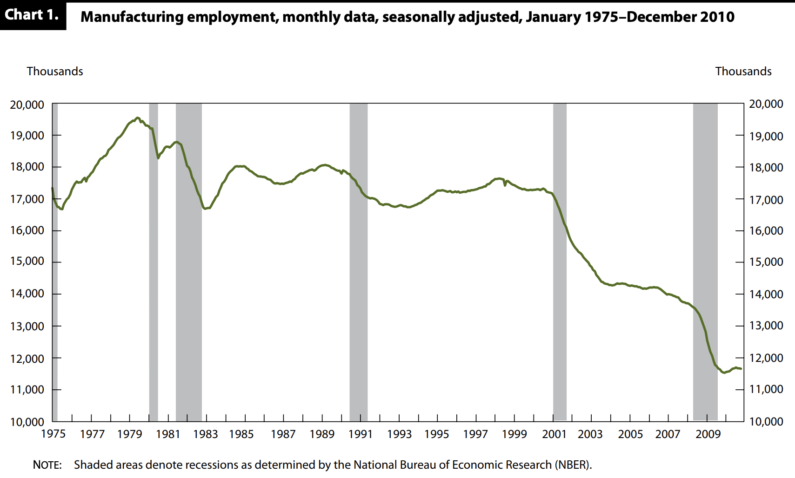Offshoring advanced manufacturing jobs is controversial. Free traders struggle with protectionists over trade regulations and tariffs. According to Theyel et al. (2018), businesses offshore “significant parts of manufacturing ... to countries with lower labor costs,” improving their margins. They claim offshoring conflict originated “as concerns about the loss of jobs and national know-how”. Onshore manufacturing jobs peaked in 1969, the same year the U.S. formally recognized the People’s Republic of China (China, 2019), and have declined ever since (Chart 1, Barker). Stettner et al. (2017) claim the “entrance of China into the World Trade Organization [in 2001] was responsible for 2.4 million job losses.” The word “outsource” would only enter English books a decade later, increasing in popularity each year since (Google Ngram, 2019).

Manufacturing executives, laborers, economists, populists, consumers, and environmentalists all compete to influence U.S. trade policy. Free traders appeal to values such as free enterprise prosperity and consumers’ purchasing power. Conversely, protectionists associate their positions with national pride, and economic equality, and conservationism.

Automation looms on the horizon and plays a larger role in job loss than trade.

**Review of Research**

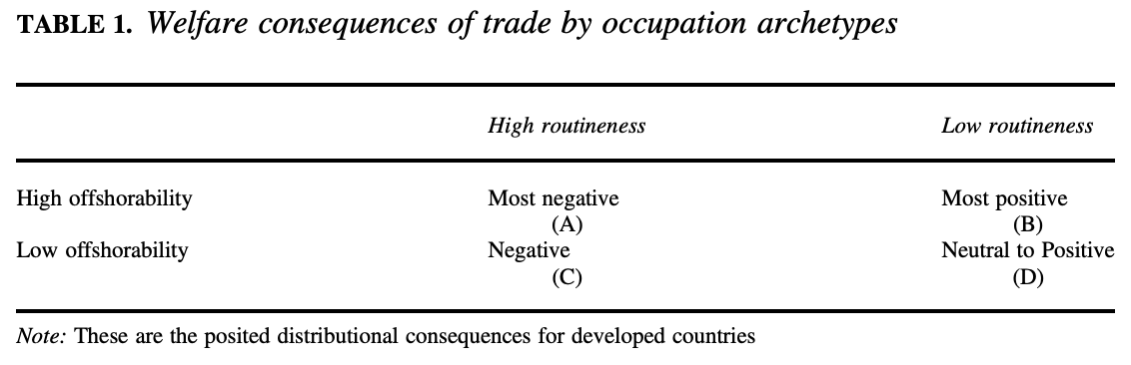 Offshoring is entrenched in America’s economic history. According to Sirkin et al. (2012) in a BCG report, “The United States has been losing factory jobs for so long that many observers have all but written off manufacturing as a meaningful part of America’s economic future.” Owen and Johnston (2017) define offshorability as “the degree to which an individual’s occupation is intensive in tasks that can be provided from abroad”; routineness is a job’s replicability (Table 1). They contend that “those who are in nonroutine, highly offshorable jobs (Group B) are most likely to benefit from trade, and are thus likely to support trade liberalization.” Lindsay Oldenski (2014) finds that offshoring further polarizes wages between groups B and C: “the intensity with which occupations use nonroutine tasks determines which workers gain or lose from offshoring.” Blinder and Krueger (2013) research differently. In surveying 3000 Americans, they conclude 28% have offshorable occupations; the sample self-declared 32% were offshorable. Ethan Kapstein (1996) explains from a macroeconomic perspective that “income inequality, job insecurity, and unemployment are widely seen as the flip side of globalization.”

Autor et. al (2012) found that only one-third of the 7.8 million manufacturing jobs lost in the U.S. between 1980 and 2010 can be attributed to offshoring; the other two-thirds are due to

forces... are more likely to be fearful of robots at work.” Frey and Osbourne (2013) estimate “47 percent of total US employment is at risk” from automation, and that “wages and educational attainment exhibit a strong negative relationship with an occupation’s probability of computerization.” Chui et al. (2015) with McKinsey find “45 percent of work activities could be automated using already demonstrated technology,” and that “60 percent of occupations could have 30 percent or more of their constituent activities automated.”

Manufacturers must keep with the frontier of technology to stay afloat. Elena Simintzi, business professor at the University of British Columbia, claims "cheap, offshore labor or technology do not replace skilled individuals; on the contrary, technology is complementary to employees' human capital” (Bena & Simintzi, 2019). According to Watanabe and Ane (2003), companies like Canon must evolve and use “new insights to manufacturing industry amidst paradigm shift from an industrial society to an information society.” This presents a challenge to smaller firms, argues Wharton professor Matthew Bidwell (2012), as “the complexity of coordinating organizational activities makes learning a slow, path-dependent, hard-to-replicate process.” This requires luxuries not all companies can access.

Trade opinions strongly correlate with political persuasion. In reviewing the work of Autor et. al, Dutt and Mitra (2018) highlight that “in the 2016 presidential election, China- affected counties experienced greater increases (or smaller reductions) in the Republican vote hare over the 2000 election” (Figure 1). Politicians react accordingly. Erica Owen (2017) argues “elected officials’ positions on trade liberalization will vary systematically according to how vulnerable their constituencies are to offshoring.” She says they use these platforms “when there is a latent shared interest” and an “actor willing to mobilize the latent interest.” Political climate

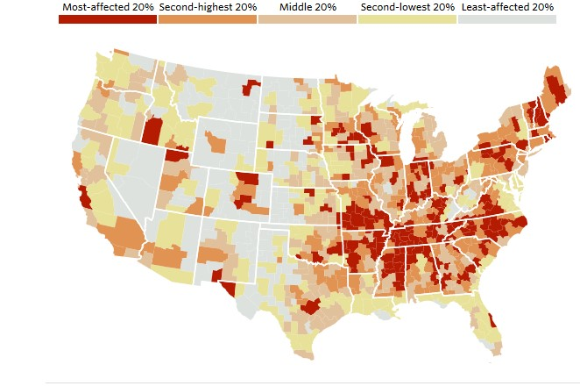in trade *partners* matters too. Pinto and Weymouth (2016) find that trade “decreases in labor-intensive industries under a left-leaning government in the partner country,” and vice versa.

Figure 1: U.S. counties affected by rising Chinese imports between 1990 and 2007 (Dutt & Mitra, 2018).

James M. Roberts (2010) describes green protectionism as “echoing the claims of radical environmental NGOs in an attempt to block imports on ecological grounds.” Douglas Yu (1994) observes “opposing sides have de- generated into a ‘Does so!’ ‘Does not!’ shouting match, arguing over whether economic growth causes more damage than it alleviates.” Companies may disguise their interests as green values, hiding in plain sight. Peiró-Signes et. al (2014) go as far as saying “nowadays, the aspects related to sustainable development, environmental management, and eco-innovation are considered crucial as building competitive advantages on them is feasible.

**Free Traders**

Manufacturers and consumers generally use bottom-up, individualistic arguments to promote free trade. Business executives outsource primarily to cut labor costs, but they also seek logistical conveniences. Brandon Webb (2015), CEO of Force12 Media, hires offshore

developers “because I don't want to get tangled up with confusing and aggressive state tax and employment laws (like Uber is now in California).” Entrepreneur David Walsh encourages “Progressive entrepreneurs [to] realize the unstoppable power of outsourcing” (Jackson, 2010). Jennifer Barnes, CEO of Optima Office, enjoys how much time offshoring frees up for her. She contends, “when CEOs apply an outsourced approach in select areas, it enables them to channel their energy into developing the company and generating revenue” (Entrepreneur, 2018). Chuck Cohn (2015), CEO of Varsity Tutors, supports offshoring because the funds that he saves on full-time staff can thus be redirected to other areas of his company.

Lowering taxes on foreign goods helps drive protectionist arguments. Bryan Riley (2019), director of the National Trade Union’s Free Trade Initiative, explains “the global trade war has [led to] two of the top ten highest point drops of all time in the Dow Industrial Average taking place after the announcement of tariffs on Chinese goods.” Some executives’ agendas are reminiscent of Reaganomics; President Reagan (1981) contended that “an equal reduction in everyone's tax rates will expand our national prosperity, enlarge national incomes, and increase opportunities for all Americans.” JP Morgan Chase CEO Jamie Dixon agrees this philosophy drives national wealth: "We needed competitive taxes... For 20 years, we've been increasingly uncompetitive, driving capital and brains overseas" (Imbert, 2018).

Offshore manufacturers use most of their marketables to curb clients’ doubts of offshoring. The Indian-Filipino outsourcing consultancy Flatworld Solutions advertises that “outsourcing and offshoring also enable companies to tap in to and leverage a global knowledge base, having access to world class capabilities” (Flatworld, 2019). Chinese manufacturer Arena Solutions attempts to bridge international barriers by advertising that their “product realization platform facilitates accurate collaboration with all teams from concept through volume

production and product support” (Arena, 2019). Baysource Global goes as far as publishing its own “Beginners Guide to Outsource Manufacturing” (Baysource, 2019). They market benefits such as “bi-lingual, integrity driven professionals,” “distribution to the world’s 2nd largest economy,” and “competency with local governance and regulatory requirements.” United Global Sourcing Incorporated (2017) uses data from past contracts to lure customers: “To date we’ve had 99 percent on-time delivery, with less than a 1 percent cost of quality and a low 14 ppm scrap rate for this client.” Astroturf group Reshoring Initiative (2019), sponsored by a variety of manufacturers, offers a “number of free tools” to businesses. Their mission is to “bring good, well-paying manufacturing jobs back to the United States” and help “companies to more accurately assess their total cost of offshoring.”

Consumers of offshorable products tend to be free traders. The median American household income in 2014 was $51,939; *Forbes* estimates the cost of an iPhone made entirely in America would be “in the $30,000 to $100,000 range” (Luk, 2018). Williamson (2018) questions “What does Donald Trump want? To save Americans from excellent washing machines offered at reasonable prices.” Boudreaux and Ghei (2017) propose free trade leads to “Prices [being] held down by more than 2 percent for every 1 percent share in the market by imports from low-income countries like China.” Low-income consumers benefit from free trade because they “spend a higher share of their income on tradeable goods” (Bellafiore & Riley, 2017). Those who hold these occupations, which are highly offshorable yet nonroutine, are the most likely to support free trade (Owen & Johnston, 2017).

**Macroeconomic Protectionists**

Manufacturing employees, populists, and environmentalists generally use top-down,

broad arguments to promote protectionism. Manufacturing workers fear their jobs will be replaced by overseas counterparts. Sergey Gorelik (2018) sums up his plight: “Well, after 23 years working for Compressor Controls I lost my job, which was outsourced. In corporate America you’re just a number and after a year of training people to take over my job my number was up.” Reddit user Allthingstothecloud took to a digital support group to break the news that his/her “entire IT department is being outsourced” (Reddit, 2017). Dozens of supportive, community-centered comments ensued and comforted him/her.

Workers find strength in numbers, also turning to labor unions. According to Ben Casselman of FiveThirtyEight (2016), manufacturing workers average $20.80 an hour in Michigan, where 23% belong to unions, as opposed to $18.84 in South Carolina, where less than 2% are in unions. Casselman claims unions “help explain why middle class is healthier in the Midwest than in the Southeast.” The AFL-CIO (2014) represents over twelve million workers like Gorelik and lobbies protectionist policy, such as “offshore profits of U.S. corporations must be taxed at the same rate and at the same time as their domestic profits.” The International Brotherhood of Teamsters (2018) labor union publishes slogans such as “NAFTA KILLS!”, protesting in wake of President Trump’s threats to leave the agreement. Dave Green, the local union president of the General Motors plant in Lordstown, Ohio, says “When Trump campaigned here, he told us [hold on to your homes because the ‘jobs are coming back](http://time.com/4874161/donald-trump-transcript-youngstown-ohio/).’ But the reality is that people keep getting pink slips, and now hundreds of my members have put their homes up for sale to look for jobs elsewhere” (Geevarghese, 2018).

Populists such as Trump, who may be free traders to cut costs of their companies, appeal to the populous by aligning their interests with nationalist ideas. He took advantage of a perfect pre-electoral political climate. Steve Goldstein (2019) of MarketWatch brings to light that “loss

of the highly paid jobs for the high-school educated ... set the stage for the election of President Donald Trump and his brand of populism.” Trump said in his inaugural address “We must protect our borders from the ravages of other countries making our products, stealing our companies and destroying our jobs” (Trump, 2017). He warned businesses later that year “if you leave, it’s going to be very tough for you to ... sell your product back into our country” (Fortune, 2017). He also tweeted “trade wars are good, and easy to win” (BBC, 2018). Vice President Mike Pence and President Xi Jinping traded blows at the 2017 Asia-Pacific Economic Cooperation Summit (SCMP 2017). Jinping opened with “protectionism will not solve problems but add uncertainty to the world economy.” Pence countered: “China has taken advantage of the United States for many, many years and those days are over... The US will not change course until China changes its ways.”

A strange alignment of agendas exists between some workers and Trump. Protectionist workers, many of whom are liberal, support Trump’s populist agendas. When Trump failed to follow through on his promises, though, liberal-progressives lashed back. Renee Elliott (2018), an employee of Carrier whose job was outsourced, attests “I want Trump to remember me and all those voters he betrayed. I want him to know that he's not making America great again for workers like me.” Randall Troyer of Elkhart, Indiana, is “62 and worried about retirement.”  He voted for Trump “because he promised to save jobs.”  But his “plant is moving to Mexico and Trump hasn’t stopped it” (Geevarghese, 2018). In a Youtube vlog titled “Trump...is the President ...Great ...I got my job stolen how about you?”, user Nova Scotia (2017) “I showed up to work—there was a Peruvian lady in my spot at work.” She explains that she was raised from $9 to $11 an hour, offered full time employment, then the next day “she stole my job.” Good Jobs Nation (2017) published a report claiming “we found no evidence that the Trump administration has

done anything to halt, or even slow, the outsourcing of American jobs by federal contractors.” In response, Trump creates a complex yet transparent argument: “I want to deal with the people in the union, not the heads of the union, because the heads of the union are not honest people” (Quinn, 2019). Here he attempts to weaken unions while still connecting with their populist members. Non-populist republicans, like Paul Ryan, loathe protectionism. In response to Trump’s aluminum tariffs on China, Ryan states, “I disagree with this action and fear its unintended consequences... Our economy and our national security are strengthened by fostering free trade with our allies” (BBC, 2018). Trump picks an abnormally diverse assortment of allies.

Many companies villainize offshoring to feed off the disappointment from lost jobs. Although most firms like Parallax claim they “are inundated on a daily basis with emails and phone calls from companies in India”, they ever-so-valiantlyrefuse to outsource (Dudley, 2010). The Californian firm Get Energy (2016) presents stories of electrical workers who lost jobs to offshoring, then plugs “If you are interested in getting your electricity from a local company who has never outsourced and will never outsource jobs to a foreign country, give us a call.” The technology consultancy Liquid Interactive (2016) says “we outsource, ultimately for our clients, but also because it is the right thing to do.” Big Fish (2017), a Floridian mobile app developer, calls outsourcing “downright scary” and proposed the question “Who the heck would be developing for us anyway?”. These companies make sure to inform clients of mysterious faraway lands and job loss to maximize conversion rates.

Green protectionism is an ethical dilemma. The WTO (2019) claims “a balance is needed, between safeguarding market access and protecting the environment”. It acknowledges that green virtues can be used in “inappropriate” claims and proposes this abstract balance. Because green protectionism cannot be fully identified by free traders, it becomes a powerful

weapon for protectionists. Harvard economist Dani Rodrik finds “modern agreements can foster a sneaky sort of protectionism” (Nelson 2018). He says they are easily “captured by an alternative set of special interests” and “may make things worse just as easily as [they make] them better”. In 2009, the EU adopted a directive that limited the import of biofuels (Fjellner & Munkhammar, 2010). Because “studies have shown that it is not possible to meet the EU's biofuels needs with domestic raw material production”, such policy is fraudulent. The Lacey Act, enacted in 1900 then amended in 2008 to severely restrict the importing plant products (Forest Legality, n.d.), makes the products “less competitive” and is “part of a spreading green protectionist disease” (Wilson, 2010).

**Impact of Technology**

Innovation dilutes free traders’ and protectionists’ agendas. Technology in manufacturing helps explain why Trump fights to manufacture onshore but cannot create jobs: manufacturing is becoming jobless. Larry Elliott (2018), economics editor of *The Guardian*, fears a new Amazon Go store in Seattle “brings us one step closer to the end of work as we know it,” proposing a “robot tax”. Fear is widespread. Economists David Autor and Anna Salomons (2017) ask “Is the Robocalypse Now?” and answer with “maybe,” that “machine capability... increasingly encroaches on human job tasks.” Oppenheimer (2019) divides the future of society into three groups: “the elites,” “those who provide personalized services to the elite,” and “the victims of technological unemployment.” Chief economist at Google Hal Varian is less worried: “Automation doesn’t generally eliminate jobs. Automation generally eliminates dull, tedious, and repetitive tasks. If you remove all the tasks, you remove the job. But that’s rare” (Snyder,

2019). Doug Bloch, political director for the Teamsters’ Joint Council, resists the idea of “a robot apocalypse” (Greenhouse 2018).

A collection of simple websites illustrates worker’s fears. They use the persuasive power of specificity (Garrett, 2007) to convince worried workers firing is imminent. The front page of robots-taking.itsmycareer.com attempts to profit off this fear with the headline “We’ve found __ Robots Taking Jobs Near You!” (n.d.) Willrobotstakemyjob.com allows visitors to enter their occupations and returns a percent chance the job is automated. Entering “welder” returns a 94% probability of automation and the text “You are doomed” (n.d.). Replacedbyrobot.info serves the same function; they are both based off the same research at Oxford (Frey & Osbourne, 2013).

**Conclusion**

The two pitted sides in this research question use non-binary arguments. Its answer is more complex than claiming protectionists and free traders are both homogeneous social groups with aligned agendas. In several cases, such as the working class, participants transcend trivial boundaries. Conservative, rural workers who are commonly protectionists policy may be free traders because they want low tariffs and prices on goods they consume. Liberal, urban workersmay follow Trump’s protectionist policy because they fear their jobs may be outsourced. Emerging technology and conservation efforts further complicate these agendas. Eco-innovation disguises protectionist agendas with attractive virtues. Technology dominates all job-related arguments because it takes many more jobs away from Americans than does offshoring. Americans overreact to persuasive, misleading interests that are disguised as values, and seek comfort in social media and unions. Further investigation of other offshorable industries, such as

IT, telemarketing, and accounting, would provide the reader with broader context of the economics and politics behind offshoring.

**References**

AFL-CIO. (2014, February 18). No Tax Incentives for Outsourcing Jobs. aflcio.org/about/leadership/statements/no-tax-incentives-outsourcing-jobs

Allthingstothecloud. (2018). Today I found out the entire IT department is being outsourced. www.reddit.com/r/sysadmin/comments/7i3zzy/today_i_found_out_the_entire_it_department_is/

Arena Solutions. (2019). www.arenasolutions.com/products/overview/

Autor, D., Dorn, D., & Hanson, G. (2012, May). The China Syndrome: Local Labor Market Effects of Import Competition in the United States. *National Bureau of Economic Research, Working Paper 18054*, 1-47.

Autor, D., & Salomons, A. (2017, June 27). Does Productivity Growth Threaten Employment? “Robocalypse Now?”. www.ecbforum.eu/uploads/originals/2017/speakers/presentations/Autor-Salomons-ECB-Productivity-Talk-v2.0.pdf

Barker, M. (2011, April). Manufacturing employment hard hit during the 2007–09 recession. *Monthly Labor Review,* 28-33.

BaySource Global. (2019). baysourceglobal.com

Bellafiore, R., & Riley, B. (2017, August 11). Clothing Suppliers Want Free Trade, Not Protectionism. www.dailysignal.com/2017/08/11/clothing-suppliers-want-free-trade-not-protectionism

Bena, J., & Simintzi, E. (2019). Machines Could Not Compete with Chinese Labor: Evidence from U.S. Firms’ Innovation. *SSRN,*1-20.

Bidwell, M. J. (2012). Politics and Firm Boundaries: How Organizational Structure, Group Interests, and Resources Affect Outsourcing. *Organization Science,23*(6), 1622-1642.

Blinder, A., & Krueger, A. (2009). Alternative Measures of Offshorability: A Survey Approach. *Journal of Labor Economics,31*(S1), 97-128.

Boudreaux, D. J., & Ghei, N. (2018, May 30). The Benefits of Free Trade: Addressing Key Myths. www.mercatus.org/publication/benefits-free-trade-addressing-key-myths

Cannon, K. (2016, September 6). Why We Don't Outsource. www.liquidint.com/blog/why-we-don-t-outsource/

Case Studies: Cast and Machined Components. (2017). www.unitedgs.com/case-studies/

Casselman, B. (2016, May 13). Americans Don't Miss Manufacturing - They Miss Unions. fivethirtyeight.com/features/americans-dont-miss-manufacturing-they-miss-unions/

China: Establishment of Diplomatic Relations with PRC(2019). history.state.gov/countries/china

Chui, M., Manyika, J., & Miremadi, M. (2015, November). Four fundamentals of workplace automation. www.mckinsey.com/business-functions/digital-mckinsey/our-insights/four-fundamentals-of-workplace-automation

Cohn, C. (2015, August 04). Strategic Ways To Outsource, And When To Do It. www.forbes.com/sites/chuckcohn/2015/03/19/strategic-ways-to-outsource-and-when-to-do-it/#e28e1042fcbf

Dekker, F., Salomons, A., & Van der Waal, J. (2017). Fear of robots at work: The role of economic self-interest. *Socio-Economic Review,15*(3), 539-562.

Dudley, L. (10, June 20). Why We Don't Outsource. parall.ax/blog/view/361/why-we-don-t-outsource

Dutt, P., & Mitra, D. (2018, April 17). The Paradox of Protectionist Populism. knowledge.insead.edu/blog/insead-blog/the-paradox-of-protectionist-populism-8896

Elliott, L. (2018, February 01). Robots will take our jobs. We'd better plan now, before it's too late. *The Guardian*. www.theguardian.com/commentisfree/2018/feb/01/robots-take-our-jobs-amazon-go-seattle

Elliott, R. (2018, February 02). I was betrayed by Donald Trump. www.chicagotribune.com/news/opinion/commentary/ct-perspec-carrier-jobs-trump-0205-story.html?fbclid=IwAR1bCLW4fIOxbs9tmueRVM2F3JEqiNh0MMW6DJRd2fNL7gpM8BvipnADnU8

Fjellner, C., & Munkhammar, J. (2010, August 2). Stop green protectionism. Retrieved from <https://euobserver.com/opinion/30550>

Flatworld Solutions, (2019). Top 10 Reasons to Outsource. www.flatworldsolutions.com/articles/top-ten-reasons-to-outsource.php

*Fortune* (2017, October 10). 'It's Both a Carrot and a Stick.' Trump Has a New Plan to Punish Companies That Outsource Overseas.

Frey, C. B., & Osborne, M. A. (2013). The Future of Employment: How Susceptible are Jobs to Computerization? *Oxford Martin Programme on Technology and Employment,*1-77.

Garrett, C. (2007, August 27). The Persuasive Power of Specificity. www.copyblogger.com/specificity-in-copywriting/

Geevarghese, J. (2018, September 02). Trump is failing to bring back American jobs. thehill.com/opinion/white-house/404629-trump-is-failing-to-bring-back-american-jobs

Get Energy. (2016, August 18). I Lost my Job to Outsourcing: Locals' Stories. getenergy.ca/local/i-lost-my-job-to-outsourcing-locals-stories/

Goldstein, S. (2019, January 04). U.S. enjoys best manufacturing jobs growth of the last 30 years. www.marketwatch.com/story/manufacturing-employment-in-the-us-is-at-the-same-level-of-69-years-ago-2019-01-04

Google Ngram Viewer: Outsource. (2019, March). books.google.com/ngrams/graph?content=outsource&year_start=1940&year_end=2008&corpus=15&smoothing=3&share=&direct_url=t1;,outsource;,c0#t1;,outsource;,c0

Good Jobs Nation. (2018, August). Promises Broken #1: Trump’s Government is America’s Top Low Wage Job Creator. actionnetwork.org/user_files/user_files/000/025/123/original/Broken_Promises_07202018v15.pdf

Gorelik, S. (2018, September 29). Facebook Post. www.facebook.com/plugins/post.php?href=https://www.facebook.com/sergey.gorelik.1/posts/2010856198934760&width=500

Greenhouse, S. (2018, May 04). Unions Face The Fight Of Their Lives To Protect American Workers. www.huffingtonpost.com/entry/american-workers-jobs-inequality-union-automation_us_5ae043f9e4b061c0bfa32e0c

E. (2018, December 21). How to Utilize Fractional Business Services to Grow in 2019. www.inc.com/entrepreneurs-organization/game-changer-benefits-of-outsourcing-business-functions.html

Imbert, F. (2018, July 30). Dimon says Trump's tax cut and deregulation have 'accelerated growth'. www.cnbc.com/2018/07/30/dimon-says-the-presidents-tax-cut-and-other-efforts-have-accelerated.html

Jackson, N. M. (2010, January 16). How to Build a Better Business with Outsourcing. www.entrepreneur.com/article/204652

Kapstein, E. B. (1996). Workers and the World Economy. *Foreign Affairs*, 75(3), 16. JSTOR.

Lo, K., Jeong-ho, L., & Jaipragas, B. (2018, November 19). Gloves off as Xi Jinping, Mike Pence exchange barbs at Apec summit. www.scmp.com/news/china/diplomacy/article/2173739/xi-jinping-mike-pence-trade-barbs-over-trade-war-apec-summit

Luk, G. (2018, January 17). How Much Would an iPhone Cost if Apple Were Forced to Make It in America? *Forbes*. www.forbes.com/sites/quora/2018/01/17/how-much-would-an-iphone-cost-if-apple-were-forced-to-make-it-in-america/#7c5ee4bc2d2a

Nelson, E. (2018, February 23). Modern free trade agreements are increasingly stuffed with protectionist measures. qz.com/1213541/harvard-economist-dani-rodrik-shows-how-free-trade-agreements-increasingly-include-protectionist-measures/

S. (2017, June 06). No, We Don't Outsource Abroad. Here's Why... discoverbigfish.com/blog/no-we-do-not-outsource-abroad.html

Nova Scotia. (2017, January 30). Trump...is the President ...Great ...I got my job stolen how about you? www.youtube.com/watch?v=JakOrWhITo8

Oldenski, L. (2014). Offshoring and the Polarization of the U.S. Labor Market. *ILR Review,67*(3), 734-761.

Oppenheimer, A. (2019). *Robots Are Coming! The Future of Jobs in the Age of Automation*. Vintage.

Owen, E. (2017). Exposure to Offshoring and the Politics of Trade Liberalization: Debate and Votes on Free Trade Agreements in the US House of Representatives, 2001–2006. *International Studies Quarterly,61*(2), 297-311.

Owen, E., & Johnston, N. P. (2017). Occupation and the Political Economy of Trade: Job Routineness, Offshorability, and Protectionist Sentiment. *International Organization,71*(04), 665-699.

Peiró-Signes, A., Segarra-Oña, M., & Alvarez, C. M. (2013). Why do Services and Manufacturing Firms Envision Environmental Innovation Differently? A Path-Model Comparison. *Polish Journal of Environmental Studies,23*(5), 1691-1697.

Pinto, P. M., & Weymouth, S. (2016). Partisan Cycles in Offshore Outsourcing: Evidence from U.S. Imports. *Economics & Politics,28*(3), 233-261.

Quinn, M. (2019, March 20). Trump says union leaders are 'not honest people'. www.washingtonexaminer.com/news/trump-says-union-leaders-are-not-honest-people

Reagan, R. (1981, February 18). *Address Before a Joint Session of the Congress on the Program for Economic Recovery*. Speech presented in The White House, Washington, DC. www.reaganlibrary.gov/21881a

Reshoring Initiative. (2019). reshorenow.org/

Riley, B. (2019, February 6). Open Letter to President Trump and Congress: Work Together to Improve Trade Policy. www.ntu.org/publications/detail/open-letter-to-president-trump-and-congress-work-together-to-improve-trade-policy

Roberts, J. M. (2010, August 11). Green Protectionism. www.heritage.org/environment/commentary/green-protectionism

Sirkin, H. L., Zinser, M., Hohner, D., & Rose, J. (2012, March 22). U.S. Manufacturing Nears the Tipping Point. www.bcg.com/publications/2012/manufacturing-supply-chain-management-us-manufacturing-nears-the-tipping-point.aspx

Snyder, B. (2019, March 11). Jobs-stealing robot fears are misplaced, say experts. www.therobotreport.com/jobs-fears-robots-misplaced/

Stettner, A., Yudken, J., & McCormack, M. (2017, June 13). Why Manufacturing Jobs Are Worth Saving. Tcf.org/content/report/manufacturing-jobs-worth-saving/?session=1#easy-footnote-bottom-4

Teamsters. (2019). Retrieved from https://teamster.org/

Theyel, G., Hofmann, K., & Gregory, M. (2018). Understanding Manufacturing Location Decision Making: Rationales for Retaining, Offshoring, Reshoring, and Hybrid Approaches. *Economic Development Quarterly,* *32*(4), 300-312.

Trade wars, Trump tariffs and protectionism explained. (2018, July 26). www.bbc.com/news/world-43512098

Trump, D. (2017, January 20). *Inaugural Address*. Address, Washington, DC.

U.S. Lacey Act. (n.d.). Retrieved from https://forestlegality.org/policy/us-lacey-act

Watanabe, C., & Ane, B. (2003). Coevolution of Manufacturing and Service Industry Functions. *Journal of Services Research,3*(1), 102-118.

Webb, B. (2015, August 03). A Navy SEAL-turned-CEO explains why companies are outsourcing in droves. *Business Insider.*

Williamson, K. D. (2018, January 30). Will the Liberals Take the Lead on Trade? www.nationalreview.com/2018/01/free-trade-will-liberals-take-lead-now/

Wilson, T. (2010, August 06). Free trade infected by 'green protectionism'. www.washingtontimes.com/blog/watercooler/2010/aug/6/free-trade-infected-green-protectionism/

What is the WTO? (2019). www.wto.org/english/thewto_e/thewto_e.htm

Yu, D. (1994). Free Trade Is Green, Protectionism Is Not. *Conservation Biology,8*(4), 989-996.